**UI Design Document**

This documents will have mock screens for most of the functionalities of the app.

1. App Icon on a phone (Below is a sample. We can decide on the actual icon) - Ajay please add different Logos here for us to choose from



1. Click on the Icon and the App opens and the Loading screen comes up before the Login/Signup or Home screen. (In design) – Mydeen is deciding
2. Login or Home screen appears once the App loads. **‘Create a New I-go-out account’ instead of Sign up? Use the same format as Login button**

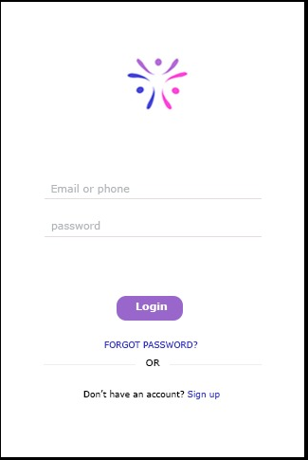

Do we need a get OTP to sign in for Phone?

What about Facebook or Google login?

1. When the user wants to sign up:

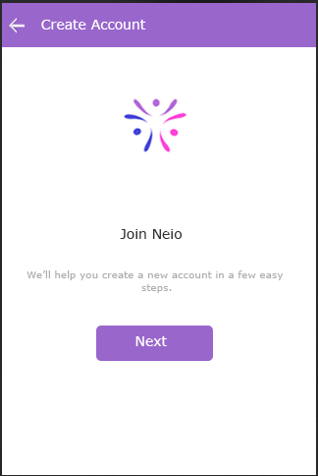

1. Enter their name and click on Next! **Instead of What’s your name – Enter your name can be used**

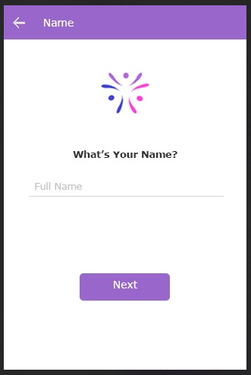

1. Enter their Gender and Click on Next (Shall we say not listed or other. Also Enter or Select your Gender sounds polite)

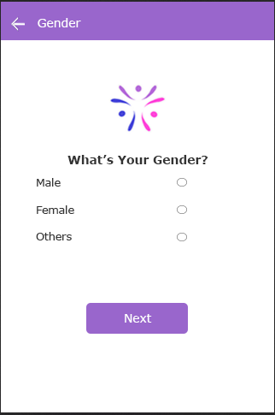

1. Enter the birthdate and click on Next!

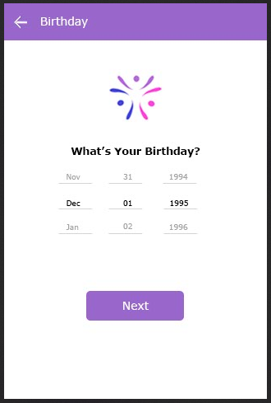

1. Enter their email id or phone number and click next! **(Email one line and Phone one line shuld be provided. Email id is mandatory while phone can be optional?) – Also Account confirmation Page needs to be designed.**

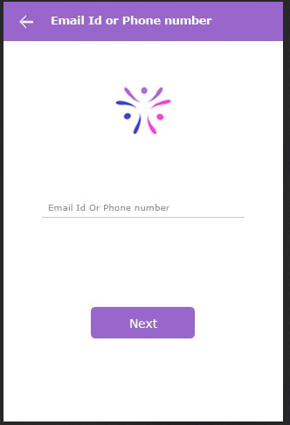

1. Choose three or more of your favourite categories (shall we say interests or categories)

0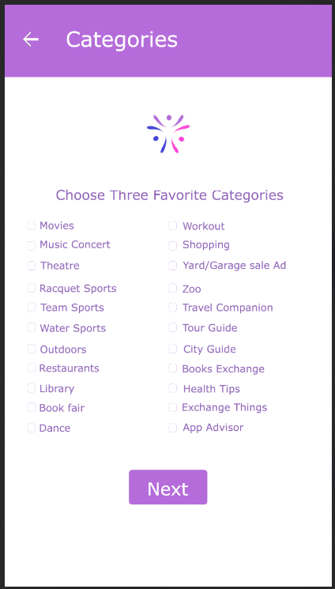

Select the country and click on Next!

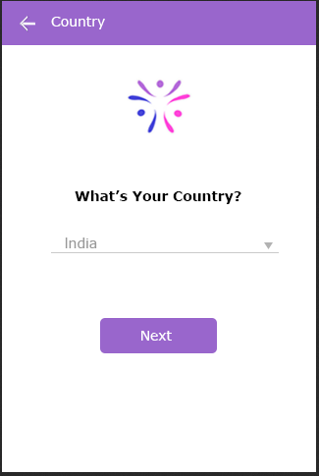

Enter State and click on Next! – State/province

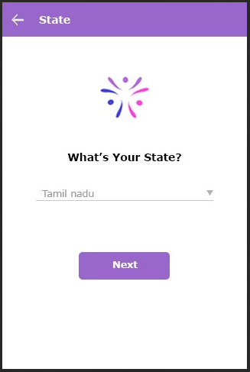

**We need to show a GPRS to map their co – ordinates to get the location they want to set as theirs in the next screen or display the city option and then a list of all localities in that city.**

**Screenshot for Username? – Or shall we use their email id as the userid for our system tables**

**Select a password for the App (Give the rules for creating a password. 8 characters atleast with special characters and numbers)**

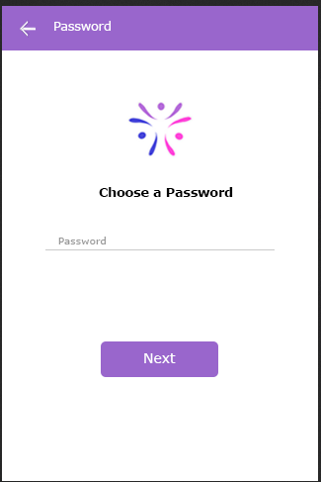

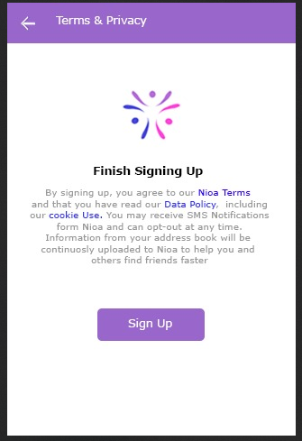

**User account will be created and will be taken to the user Home screen. Events for that location should be displayed in the Home screen list. And then list of groups which they have subscribed to (The Group concept can be completely let off if we are going by number of members for an account).**

**Verification screen for OTP or Email confirmation - missing**

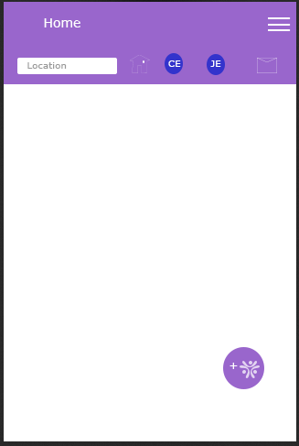

**In the Home page, we need to list the events depending upon the Location and categories.**

**And if some one clicks on the Event, it should take to a Page where it displays the event details and from there we can respond.**

**Choose different categories Link also can be provided at the Right bottom corner/Right Top cornerof the Home screen**

**This side menu should say Joined Events not response Event. Did you remember we changed it?**

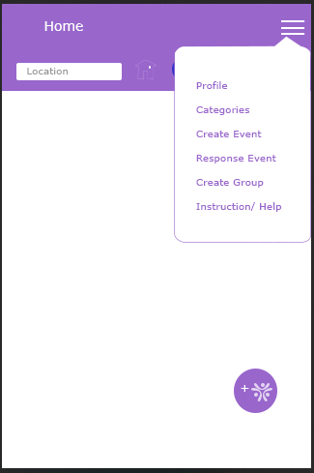

**The Create Event page will allow the users to create an event.**

**It should be Category, Sub Category,Max. no.of. participants**

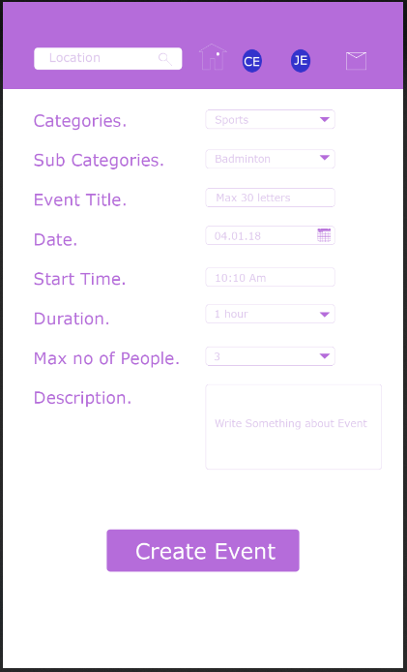

**This should be the Respond Page. And the Query should be slightly disabled. Only when someone types more than 30 characters in the message it should be enabled.**

**It should be Category, Sub Category,Max. no.of. participants**

**Respond Page!**

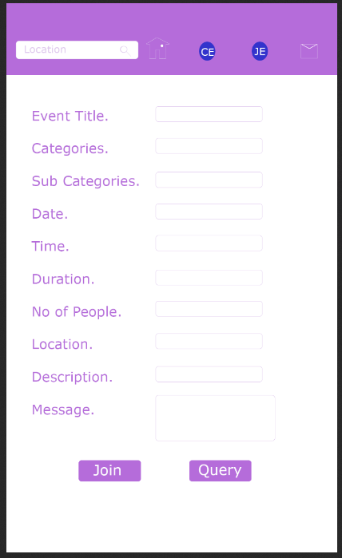

**Also we need a Profiles search page.**

**Following need to be added.**

1. **Joined Events page – Lists the Events under different categories the user has joined**
2. **Event Display page – when someone clicks on an event from the list displayed in Home page. A Join/Query button should be provided there at the end of the page. Clicking on one of them should take them to the Respond Page.**
3. **Heading are missing in Create Event, Join/Respond Event pages.**

**Heading should be: Create an Event, Join the Event**